WEST LONDON WASTE AUTHORITY
Report of the Waste Minimisation Manager | 29 March 2019
Waste Minimisation Update
SUMMARY
This report provides an update on the Authority’s Waste Minimisation activities.
RECOMMENDATION(S)
The Authority is asked to:

Note the information within this report.

- Introduction – The Waste Minimisation Team delivers the campaigns that focus on minimising the seven key waste streams of food, textiles, waste electrical and electronic equipment, nappies, bulky household waste, plastics and dry mixed recycling. The team is also responsible for the Authority’s website, intranet, social media, and media communications.

Key waste streams
  - Food Waste
    - 516 flats across seven sites in Richmond began a trial for food waste recycling collection for flats on the 20th of October. Working with managing agents of the sites, the Waste Minimisation team delivered letters, leaflets, caddy liners, indoor caddies and communal bins to residents around the Twickenham, Mortlake and Kew areas of the borough.

As of the beginning of March 2019, collections have totalled at 4.6 tonnes since the project started. Current average weekly collection weight to date stands at 230kg, which suggests an overall estimated household participation rate of 39%. There was a decline of food waste collected during February; however, following a second round of intervention of doorstep engagement, mobile service survey and the delivery of caddy liners was carried out towards the end of February, participation sharply increased to 71% equivalent to average 460kg food waste collected per week.

The mobile survey introduces new technology implemented to educate residents and to gather responses with fewer resources needed and no door knocking. The use of these mobile surveys will be expanded increase engagement across West London. Results of the survey will be included in the June report.

The pilot is currently achieving above the 70% active participation target with each property producing at least 1.25kg of food waste, totalling to 451.5kg per collection across the seven sites. To maintain participation, the team will continue with communication activities including placing encouraging posters at sites and carrying out regular maintenance of bins.

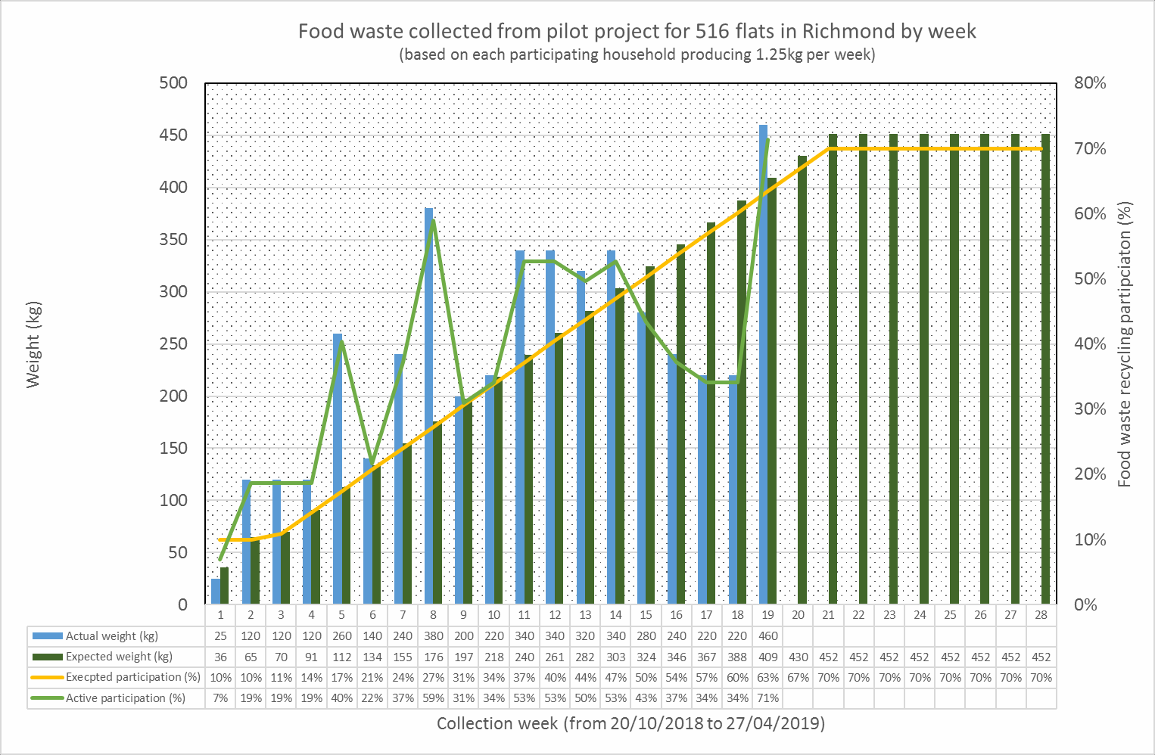

Waste electronic and electrical equipment (WEEE)
    - A new kerbside WEEE collection trial covering 11,000 properties in Harrow, funded by DEFRA commenced in June 2018. The pilot ran weekly for six months to encourage diversion of electrical items from the general residual stream.

The pilot yielded 8.21 tonnes of WEEE items collected from 522 households equating to an average of 16.75kg per collection. Participation rates were low, at 4.7%.

Key learnings from the pilot included:

      - The pilot increased general WEEE recycling awareness; Forward Drive experienced an increased WEEE tonnage collected during the pilot period
      - Future WEEE related projects should consider having shorter collection periods as approximately 49% of requests were made during the last two months of the project
      - Majority of items collected were small and light weight (phones were the most collected item), making up approximately 11% of all items collected
Following up with the pilot, Harrow Council is looking to roll-out a WEEE collection service for one month across each ward. A business case is currently in development which will inform our response to the consultation on WEEE producer responsibility later in 2019.
Further ideas for development are the importance of secure data destruction which we will investigate trialling in a commercial environment. Additionally, the high cost of operating a WEEE collection highlighted the importance of ensuring producers pay to gather all remaining WEEE hoarded at home.

    - A series of New Year’s WEEE collections recently wrapped up covering venues including Tricycle Theatre, Richmond Civic Centre, Gayton Library and Chiswick Library. A stand was set-up with information and used as a drop-off point for residents who wished to recycle their WEEE. A total of 916 WEEE items weighing 1000kg were collected.

 | Number of WEEE items collected | Weight (kg)
Kiln Theatre | 131 | 240
Gayton Library | 320 | 280
Chiswick Library | 66 | 140
Richmond Civic Centre | 334 | 300
Uxbridge Library | 65 | 40
Total | 916 | 1000

WEEE tonnage between 2017 and 2018 has remained steady however; tonnes collected at HRRCs during January 2019 increased 27% in comparison to the previous year with three HRRCs yielding an increase.

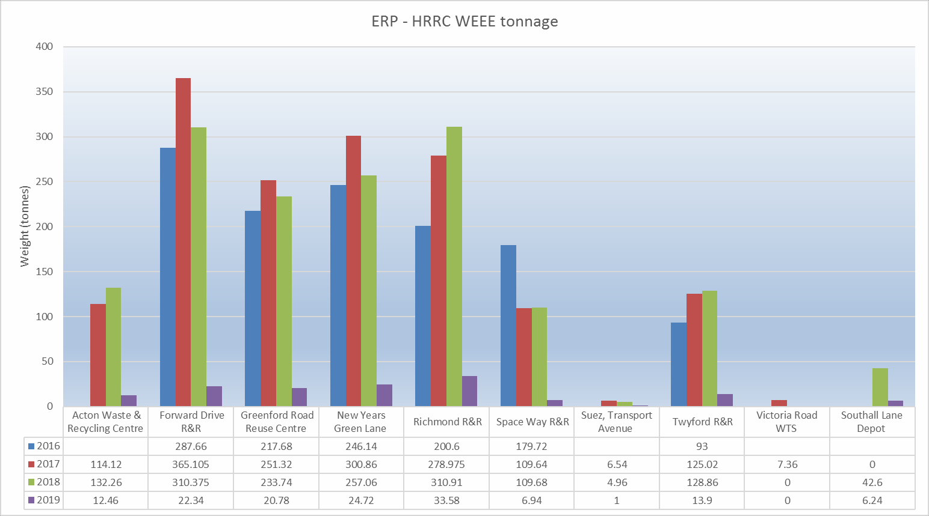
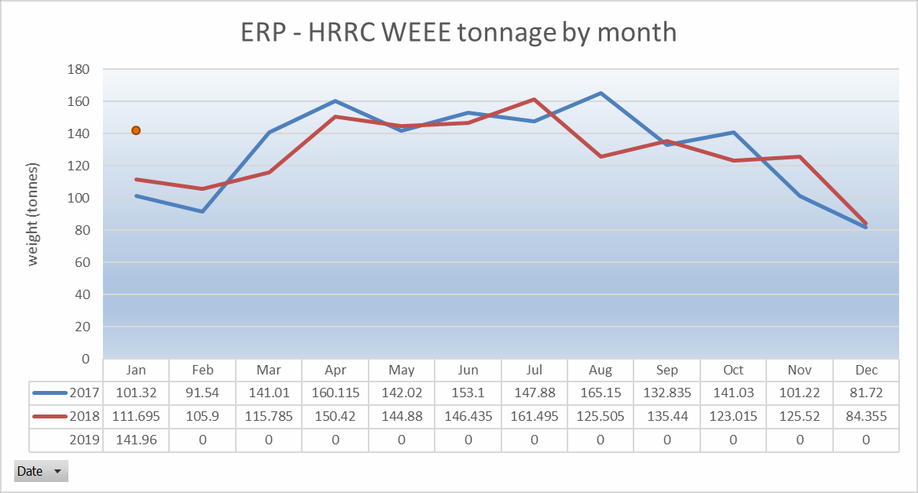

Textiles
    - In October 2017, Officers identified that the amount of textiles found in residual waste was increasing and would continue to increase due to fast fashion. An analysis of the cost of waste disposal and revenue available from textiles also revealed that revenue would increase overall and decrease per tonne as more textiles were collected. In addition a saving would be made in disposal costs per tonne of textiles diverted from waste. The Borough Environment Directors initiated a project to increase the amount of textiles collected across the six West London Boroughs using a variety of means. Officers identified the textile recyclers operating in our area and explored a number of methods to increase the amount of textiles captured.
The data collected on textiles to date indicates that we are collecting increasing volume of textiles. Promoting and increasing textile home collections has not decreased the volumes collected from banks.

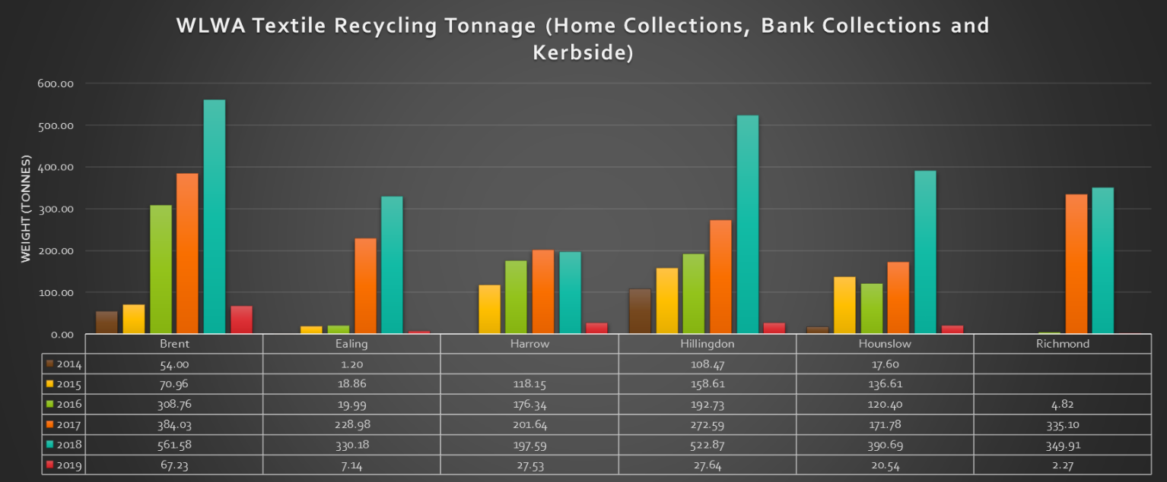
However, a large volume is still uncaptured and the amount of textiles in the residual stream is projected to reach 7% by 2021, equivalent to £3M in disposal cost for the year.
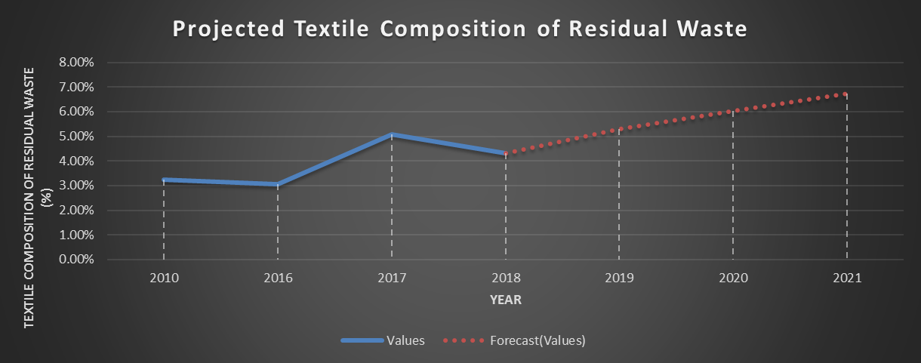

Officers are interrogating the data further to understand the impact on revenues associated with textile collections. Future development will focus on expanding the on-request collections and existing kerbside collections. We are developing shared social media resources such as infographics and video series.

Reusable Nappies
    - The uptake of the reusable nappies scheme has increased by 107% with 55 applications made during 2017 to 114 in 2018. With pronounced increase in applications, the team will increase the number of packs available from 15 to 20.

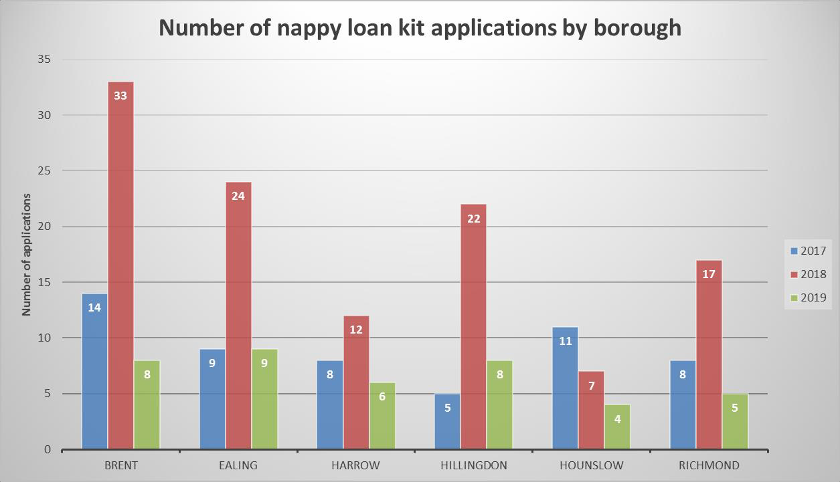

Communication
    - Appendix 1 sets out the industry events and awards that WLWA participated in during 2018/19 as leaders in treating waste as a valuable resource.

General;
    - The Waste Minimisation programme is on track.

Contact Officers | Mildred Jeakins, Waste Minimisation Manager mildredjeakins@westlondonwaste.gov.uk | 01895 546 623
 | Emma Beal, Managing Director emmabeal@westlondonwaste.gov.uk | 01895 545 515

Communications Appendix 1

Industry leadership presentations made during 2018/19

May 2018
- The power of partnerships to drive circular economy improvements Edie Live at the NEC, Birmingham
Sustainability interest audience

June 2018
- Partnership working in West London (minimising waste, increasing efficiency) Suez customer conference at SERC
Local Authority audience

October 2018
- Preventing Single Use
LARAC Conference, Nottingham
Local Authority and waste industry audience

February 2019
- Using Data to improve
MRF & markets Conference, Birmingham
Local Authority and waste industry audience

March 2019
- Food waste - Where are we now? – panellist debate
Food Waste Conference, London
Local Authority and waste industry audience

Awards entries during 2018/19

West London Waste was shortlisted for two awards during this period:
- Finalist for the MRW National Recycling Awards under the category ‘Best Public/Private Partnership’. The entry highlighted the excellent working partnership with SUEZ UK in treating West London’s waste as a valuable resource.
- Finalist at the Edie Sustainability awards for ‘Team of the year’, showcasing the various projects and events the Waste Minimisation team delivers with our six constituent boroughs.

